EXPERIMENT 5: FUEL EFFICIENCY ANALYSIS
Aim: To calculate the average fuel efficiency and percentage improvement between two car models using NumPy.
Algorithm:
- Import the NumPy library.
- Create an array of fuel efficiency values.
- Calculate the average fuel efficiency.
- Calculate the percentage improvement.
- Display the results.
Code:
import numpy as np

fuel_efficiency = np.array([25, 30, 35, 40])

average = np.mean(fuel_efficiency)
improvement = ((fuel_efficiency[1] - fuel_efficiency[0]) /
fuel_efficiency[0]) * 100

print("Average Fuel Efficiency:", average, "MPG")
print("Percentage Improvement:", improvement, "%")
Input:
Fuel Efficiency = [25, 30, 35, 40]
Output: 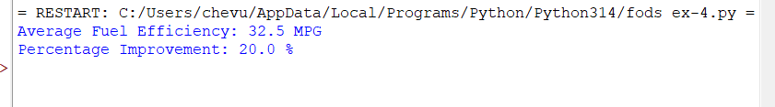
Result: Thus, the average fuel efficiency is 32.5 MPG, and the percentage improvement between the first and second car models is 20%.

